Hearts and Minds: Specialist Therapeutic Programme for Adoptive Families
RESERVATION FORM

Programme Details:
Time:  Dates: | 10 am-12 noon – Tuesday morning  Nov 3rd – 1st Dec (5 weeks/10 hours)
Venue | The course will take place virtually via Zoom for its duration.
Cost | Per person | £500
Booking | - Please return the reservation form to the email address above. An acknowledgment email will be sent to you once this form has been received and you will be placed on our reservation list.  - If you have marked on the reservation form that you wish to fund your place via the Adoption Support Fund (ASGSF), we will accept this form as your agreement for us to contact your Local Authority (LA) in order to request that they apply for funding from the Adoption Support Fund.  - Once notification of Adoption Support Fund funding is received from the LA, and confirmed to The Centre, your place(s) on the course will be confirmed to you via email.
Queries | Please contact Sarah Greenan (Therapeutic Services Team) sarah.greenan@ccsadoption.org
CCS reserves the right to levy a fee in the event of a cancellation, being 50% if 2 weeks in advance of start date, and 100% for cancellations with less than 2 weeks’ notice. Refunds cannot be given for any sessions missed.
An Outcome measurement tool will be required at the start and end of the course, in line with new ASGSF requirements

Adoptive Family Details:
Parent(s)/Key Adult Name(s) | Contact Telephone No of Parent(s)
Parent(s) Address | Parent(s) Email Contact

Main Child of Concern
Name: | DOB:
Other Family Members in The Home
Name | DOB if under 18

Funding
We wish to fund our place(s) on the course by (please circle)  *ASGSF application: if you have more than one child, please name the child that you wish the application to be made for. | Self-Funding  ……………………………………………………… | Making an application to the  Adoption Support Fund  CONSENT TO APPLY ON YOUR BEHALF – PLEASE SIGN  …………………………………………………….

Placement Information for Main Child/Children Of Concern
Date of Placement: | Placing Agency:
Date of Adoption Order: | Local Authority:
Name of LA Social Worker: | Name of LA Manager:
Concerns/Problems
Please give a outline of the current situation with your child(ren), and main areas of concern

Please give a brief birth history for your child

Please give any behaviours relating to trauma and attachment

Please outline any previous ASGSF applications (if not self funding) and previous support

How are you hoping that the Hearts and Minds programme will help your family, your desired outcomes?

Additional needs
Does anyone attending the group have any additional needs that we should consider?

Where did you hear about this course?
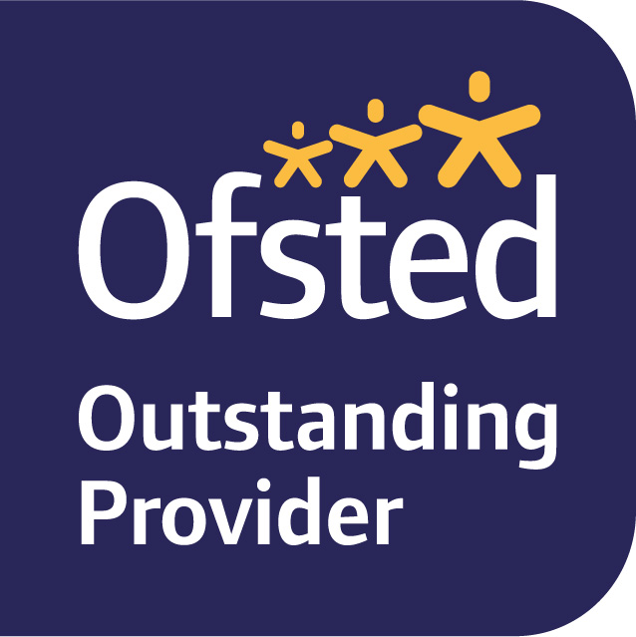
Please note that ASGSF notification is required prior to your place being confirmed and this has to be received prior to the start of the programme.

For more information about our privacy policy:
https://www.ccsadoption.org/policies/privacy-policy-for-families/

The below is a requirement for the ASGSF – all families will be asked to complete an outcome measurement tool prior to starting therapy, for a baseline and at the end of therapy. These scores are compiled by the LA for the ASGSF. No personal details are shared.
ASGSF applications cannot be made without the below signature from families.
Parental Agreement and Consent to OMT  (this must be completed prior to the application being made) | Signature:  Date:  Signature:  Date:
NB: If not wishing to agree, parent to advise Social Worker and Therapist | Reasons for parent not agreeing to be added here*  Signature:  Date:  Signature:  Date:

